**Name: salini k.b**

**Roll No:33**

**Batch:S2 MCA**

**Date:22/04/2022**

**OBJECT ORIENTED PROGRAMMING LAB**

**Experiment No.: 5**

**Aim**

**Program to Sort strings**

**Procedure**

import java.util.Arrays;

public class StringSort

{

public static void main(String args[])

{

String [] names={"anand","san","salu"};

System.out.println("array names:"+Arrays.toString(names));

Arrays.sort(names);

System.out.println("sorted array names:"+Arrays.toString(names));

}

}

**Output Screenshot**

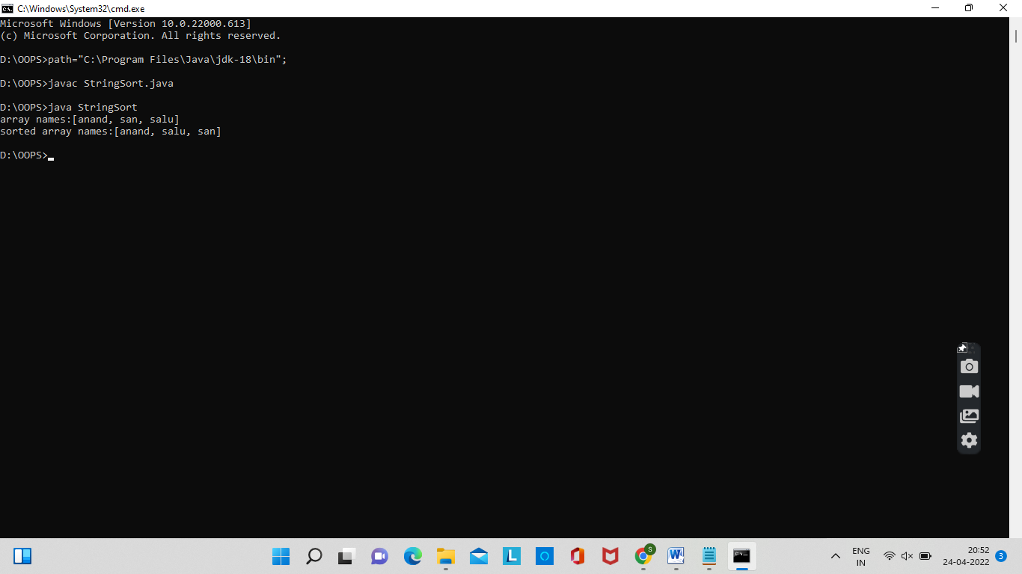

**Experiment No.: 6**

**Aim**

**Search an element in an array.**

**Procedure**

import java.util.Scanner;

public class SearchElement

{

public static void main(String[] args)

{

int n, element, flag = 0, i = 0;

Scanner s = new Scanner(System.in);

System.out.print("Enter no. of elements you want in array:");

n = s.nextInt();

int a[] = new int[n];

System.out.println("Enter the elements:");

for(i = 0; i < n; i++)

{

a[i] = s.nextInt();

}

System.out.print("Enter the element to search:");

element = s.nextInt();

for(i = 0; i < n; i++)

{

if(a[i] == element)

{

flag = 1;

break;

}

else

{

flag = 0;

}

}

if(flag == 1)

{

System.out.println("Element found at position:"+(i + 1)+""+"\n"+"searched element is:"+element);

}

else

{

System.out.println("Element not found");

}

}

}

**Output Screenshot**

